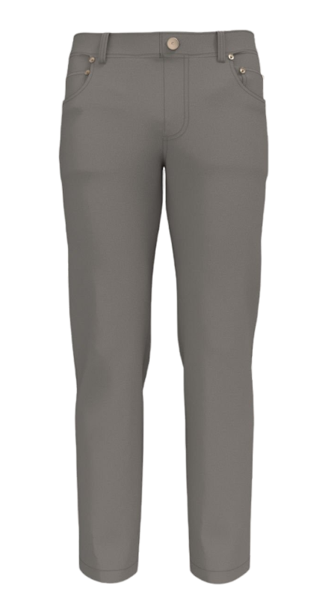96Style number : 70069773017  
Style: Men Linen Pants   
Brand: MORLY  
Size : XS – XL   
Commodity : men’s pants  
E-mail : [a0049632@gmail.com](mailto:a0049632@gmail.com)  
  
Care Address : 4-158/9 5th Cross Road, Sainikpuri, Secunderabad 500094, TS, IND   
  
**Description table**

|  |  |  |  |  |  |  |  |  |  |
| --- | --- | --- | --- | --- | --- | --- | --- | --- | --- |
| **Dim** | **Description** | **Tol (-)** | **Tol (+)** | **XS** | | | **S** | | |
| **Increment** | **Sample** | **Deviation** | **Increment** | **Sample** | **Deviation** |
| 1X1 | Waist Width | -1.00 | 1.00 | 46.00 |  |  | 50.00 |  |  |
| 1F3 | Hip Width | -1.00 | 1.00 | 36.00 |  |  | 38.00 |  |  |
| 1F6 | Thigh Width | -0.50 | 0.50 | 2.50 |  |  | 2.50 |  |  |
| 1G5 | Knee Width | -1.00 | 1.00 | 37.00 |  |  | 39.00 |  |  |
| 1H2 | Inseam Length | -0.50 | 0.50 | 21.20 |  |  | 22.00 |  |  |
| 2A1 | Outseam Length | -0.50 | 0.50 | 17.00 |  |  | 18.00 |  |  |
| 2K1 | Front Rise Length | -0.50 | 0.50 | 15.00 |  |  | 16.00 |  |  |
| 3B1 | Back Rise Length | -0.50 | 0.50 | 16.20 |  |  | 177.00 |  |  |

|  |  |  |  |  |  |  |  |  |  |
| --- | --- | --- | --- | --- | --- | --- | --- | --- | --- |
| 3B2 | Hem Opening Width | -0.50 | 0.50 | 9.10 |  |  | 9.50 |  |  |
| 3B6 | Full Length | -1.00 | 1.00 | 2.00 |  |  | 2.00 |  |  |
| 1M4 | Crotch Depth | -1.00 | 1.00 | 33.00 |  |  | 35.00 |  |  |
| 1N2 | Calf Width | -1.00 | 1.00 | 34.00 |  |  | 36.00 |  |  |
| 3C1 | Seat Width | 0.00 | 0.00 | 2.00 |  |  | 2.00 |  |  |

|  |  |  |  |  |  |  |  |  |
| --- | --- | --- | --- | --- | --- | --- | --- | --- |
| **M** | | | **L** | | | **XL** | | |
| **Increment** | **Sample** | **Deviation** | **Increment** | **Sample** | **Deviation** | **Increment** | **Sample** | **Deviation** |
| 54.00 |  |  | 58.00 |  |  | 64.00 |  |  |
| 40.00 |  |  | 42.00 |  |  | 44.00 |  |  |
| 2.50 |  |  | 2.50 |  |  | 2.50 |  |  |
| 41.00 |  |  | 43.00 |  |  | 45.00 |  |  |
| 22.80 |  |  | 23.00 |  |  | 24.00 |  |  |
| 19.25 |  |  | 20.50 |  |  | 21.75 |  |  |
| 17.25 |  |  | 18.50 |  |  | 19.14 |  |  |
| 17.80 |  |  | 18.60 |  |  | 10.70 |  |  |
| 9.90 |  |  | 10.30 |  |  | 2.00 |  |  |
| 2.00 |  |  | 2.00 |  |  | 41.50 |  |  |
| 37.00 |  |  | 39.00 |  |  | 42.50 |  |  |
| 38.00 |  |  | 40.00 |  |  | 69.00 |  |  |
| 2.00 |  |  | 2.00 |  |  | 2.00 |  |  |

**Spec Sheet**

|  |  |  |  |
| --- | --- | --- | --- |
| **Placement** | **Composition** | **Qty** | **Per rate** |
| Main Fabric | Full organic cotton | 3 | 0.25 |
| Button | Plastic/Wood | 2 | 0.75 |
| Thread | mixed fabric | 2 | 0.25 |
| Main Label | Recycled Polyster | 1 | 0.25 |
| Size Label | Recycled Polyster | 2 | 0.25 |
| Care Label | Recycled Polyster | 1 | 0.75 |
| Hang Tag | Nylon | 1 | 0.5 |

**Sample Images :  
  
